**MACHARIA ANASTASIA NDUTA**

**M-KOPA DATA ACADEMY**

**SQL -TEST**

1. **Select all the male customers from outside Nairobi.**

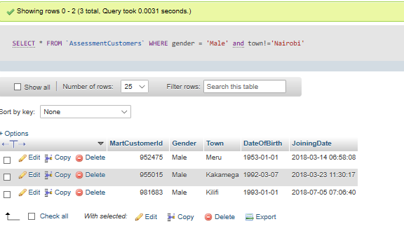

1. **Select all the customers with an extra column containing the age they were**

**when they joined. Name this column AgeWhenJoining.**

QUERY:

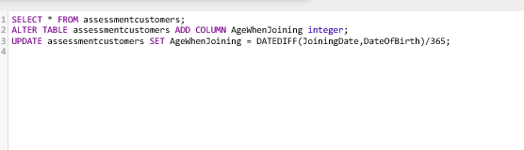

OUTPUT:

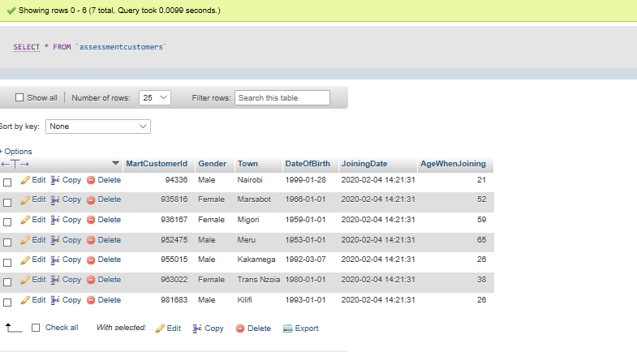

1. **3. Using the table above, calculate the average customer age when joining. Use a sub-query, CTE or temporary table.**

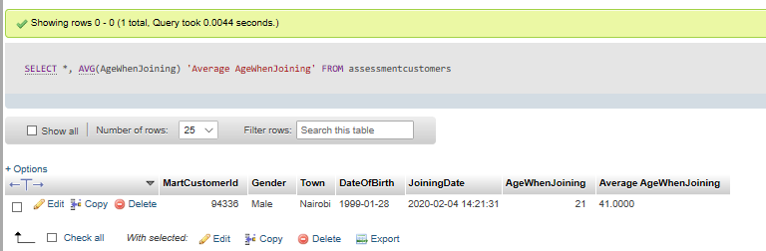

1. **4. Still using the same table, calculate the average, maximum and minimum customer age when joining per gender.**

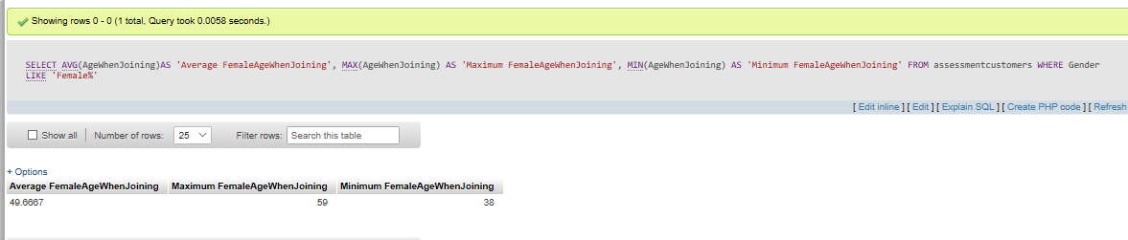

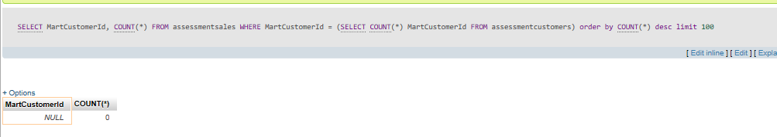

1. **5. Select the 100 customers who generated the most sales. Show their MartCustomerId, Town and the number of sales each of them generated.**

**6. How many customers have no sale? Show only the number of customers.**

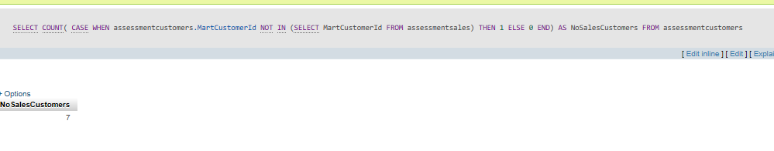

1. **7. Select all the *AssessmentSales* table with an extra column that displays 1 when the ProductSubCategory is 'M-KOPA 4' and 0 for all the other ones. Call it IsMkopa4.**

QUERY:

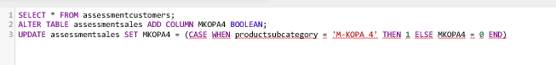

OUTPUT:

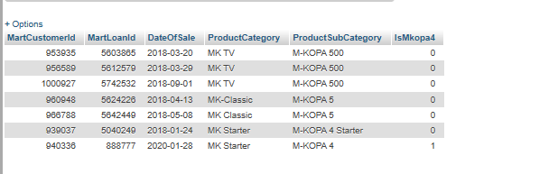

1. **8. Select all the *AssessmentSales* table with an extra column that shows the loan number for each customer: 1 if it's the customer's first sale, 2 if it's the customer's second sale etc. Call it** SaleNumber.

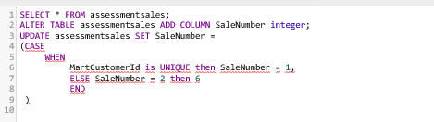

1. **9. For each customer's age category below (age today), provide the total outstanding balance and the total amount paid in on the 01/08/2018. The results must all be from a single query.**

* + - Under 30 years old

QUERY:

[**SELECT**](https://justpaste.it/redirect/7nvkz/http:/localhost:81/phpmyadmin/url*.*php%3Furl=https:/dev.mysql.com/doc/refman/5.5/en/select.html) **OutstandingBalance, SumPaidInToDate**

**From assessmentdailyloaninfo**

**JOIN assessmentsales ON assessmentdailyloaninfo.MartLoanId = assessmentsales.MartLoanId**

**JOIN assessmentcustomers on assessmentsales.MartCustomerId = assessmentcustomers.MartCustomerId**

**WHERE** [**Year**](https://justpaste.it/redirect/7nvkz/http:/localhost:81/phpmyadmin/url*.*php%3Furl=https:/dev.mysql.com/doc/refman/5.5/en/date-and-time-types.html)**(CURDATE()) -** [**Year**](https://justpaste.it/redirect/7nvkz/http:/localhost:81/phpmyadmin/url*.*php%3Furl=https:/dev.mysql.com/doc/refman/5.5/en/date-and-time-types.html)**(assessmentcustomers.DateOfBirth) < 30**

[**AND**](https://justpaste.it/redirect/7nvkz/http:/localhost:81/phpmyadmin/url*.*php%3Furl=https:/dev.mysql.com/doc/refman/5.5/en/logical-operators.html%23operator_and) **Day(assessmentdailyloaninfo.ActivityDate) = Day("2018-01-08")**

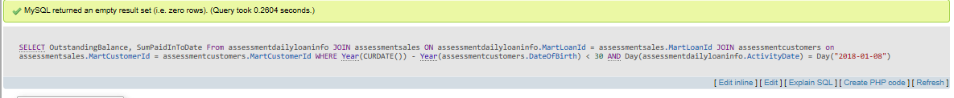

* + - Between 30 and 49 years old

QUERY:

[**SELECT**](https://justpaste.it/redirect/7nvkz/http:/localhost:81/phpmyadmin/url*.*php%3Furl=https:/dev.mysql.com/doc/refman/5.5/en/select.html) **OutstandingBalance, SumPaidInToDate**

**From assessmentdailyloaninfo**

**JOIN assessmentsales ON assessmentdailyloaninfo.MartLoanId = assessmentsales.MartLoanId**

**JOIN assessmentcustomers on assessmentsales.MartCustomerId = assessmentcustomers.MartCustomerId**

**WHERE** [**Year**](https://justpaste.it/redirect/7nvkz/http:/localhost:81/phpmyadmin/url*.*php%3Furl=https:/dev.mysql.com/doc/refman/5.5/en/date-and-time-types.html)**(CURDATE()) -** [**Year**](https://justpaste.it/redirect/7nvkz/http:/localhost:81/phpmyadmin/url*.*php%3Furl=https:/dev.mysql.com/doc/refman/5.5/en/date-and-time-types.html)**(assessmentcustomers.DateOfBirth) > 30**

[**AND**](https://justpaste.it/redirect/7nvkz/http:/localhost:81/phpmyadmin/url*.*php%3Furl=https:/dev.mysql.com/doc/refman/5.5/en/logical-operators.html%23operator_and)[**Year**](https://justpaste.it/redirect/7nvkz/http:/localhost:81/phpmyadmin/url*.*php%3Furl=https:/dev.mysql.com/doc/refman/5.5/en/date-and-time-types.html)**(CURDATE()) -** [**Year**](https://justpaste.it/redirect/7nvkz/http:/localhost:81/phpmyadmin/url*.*php%3Furl=https:/dev.mysql.com/doc/refman/5.5/en/date-and-time-types.html)**(assessmentcustomers.DateOfBirth) < 49**

[**AND**](https://justpaste.it/redirect/7nvkz/http:/localhost:81/phpmyadmin/url*.*php%3Furl=https:/dev.mysql.com/doc/refman/5.5/en/logical-operators.html%23operator_and) **Day(assessmentdailyloaninfo.ActivityDate) = Day("2018-01-08")**

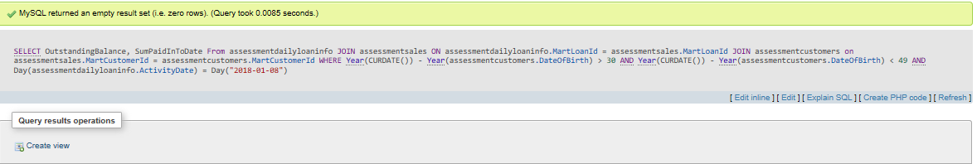

* + - Over 50 years old

QUERY

[**SELECT**](https://justpaste.it/redirect/7nvkz/http:/localhost:81/phpmyadmin/url*.*php%3Furl=https:/dev.mysql.com/doc/refman/5.5/en/select.html) **OutstandingBalance, SumPaidInToDate**

**From assessmentdailyloaninfo**

**JOIN assessmentsales ON assessmentdailyloaninfo.MartLoanId = assessmentsales.MartLoanId**

**JOIN assessmentcustomers on assessmentsales.MartCustomerId = assessmentcustomers.MartCustomerId**

**WHERE** [**Year**](https://justpaste.it/redirect/7nvkz/http:/localhost:81/phpmyadmin/url*.*php%3Furl=https:/dev.mysql.com/doc/refman/5.5/en/date-and-time-types.html)**(CURDATE()) -** [**Year**](https://justpaste.it/redirect/7nvkz/http:/localhost:81/phpmyadmin/url*.*php%3Furl=https:/dev.mysql.com/doc/refman/5.5/en/date-and-time-types.html)**(assessmentcustomers.DateOfBirth) > 50**

[**AND**](https://justpaste.it/redirect/7nvkz/http:/localhost:81/phpmyadmin/url*.*php%3Furl=https:/dev.mysql.com/doc/refman/5.5/en/logical-operators.html%23operator_and) **Day(assessmentdailyloaninfo.ActivityDate) = Day("2018-08-01")**

